

**A**

**MINI PROJECT REPORT**

ON

**“SAVED WIFI PASSWORD SNIFFER”**

Submitted in the partial fulfillment of the requirements in the IVTH Semester of

## BACHELOR OF ENGINEERING

IN

## INFORMATION SCIENCE AND ENGINEERING

BY

**SUDEEP KUDARI -[ 1NH19IS165 ]**

FOR

**COURSE NAME : MINI PROJECT COURSE CODE: ISE66**

***Under the guidance of,***

**Dr MOUNICA,** Associate professor, Dept. of ISE, NHCE

**DEPARTMENT OF INFORMATION SCIENCE AND ENGINEERING**

# NEW HORIZON COLLEGE OF ENGINEERING

(Autonomous College Permanently Affiliated to VTU, Approved by AICTE, Accredited by NAAC with ‘A’ Grade & NBA)

Ring Road, Bellandur Post, Near Marathahalli, Bengaluru-560103, INDIA [www.newhorizonindia.edu](http://www.newhorizonindia.edu/)



# CERTIFICATE

Certified that the project work entitled Text To Speech carried out by Mr. SUDEEP KUDARI, bearing USN 1NH19IS165, a Bonafede student of 4TH semester in partial fulfillment for the award of Bachelor of Engineering in Information Science & Engineering of the Visveswaraiah Technological University, Belagavi during the year 2020-21. It is certified that all corrections / suggestions indicated for Internal Assessment have been incorporated. The project report has been approved as it satisfies the academic requirements in respect of Mini Project work prescribed for the said Degree.

|  |  |  |
| --- | --- | --- |
| Name & Signature of Guide | Name & Signature of HOD | Name & Signature of Principal |
| Dr Mounica | Dr. R J Anandhii | Dr. Manjunatha |

**Examiners :**

**Name Signature**

1. ………………………………………. ………………………………..

2. ………………………………………. …………………………………

**ABSTRACT**

A pleasant python application where the saved Wi-Fi password from the system can be sniped out.

In windows 10, Wi-Fi SSID and passkey is saved in the system directories. This application works using some windows PowerShell commands, using those commands the saved list of Wi-Fi passwords can be drawn out.

This application uses python modules and commands to automate the task.

After extracting the list of saved Wi-Fi details, it sends mail to desired mail address with the subject as Wi-Fi details.

This project uses re, subprocess and smtplib modules for various processes.

## ACKNOWLEDGEMENT

Any project is a task of great enormity and it cannot be accomplished by an individual without support and guidance. I am grateful to a number of individuals whose professional guidance and encouragement has made this project completion a reality.

I have a great pleasure in expressing my deep sense of gratitude to the beloved Chairman Dr. Mohan Manghnani for having provided me with a great infrastructure and well-furnished labs.

I take this opportunity to express my profound gratitude to the Principal Dr. Manjunatha for his constant support and management.

I am grateful to Dr. R J Anandhi, Professor and Head of Department of ISE, New Horizon College of Engineering, Bengaluru for her strong enforcement on perfection and quality during the course of my project work.

I would like to express my thanks to the guide Dr Kalai Vani**,** Associate professor, Department of ISE, New Horizon College of Engineering, Bengaluru who has always guided me in detailed technical aspects throughout my project.

I would like to mention special thanks to all the Teaching and Non-Teaching staff members of Information Science and Engineering Department, New Horizon College of Engineering, Bengaluru for their invaluable support and guidance.

SUDEEP KUDARI

1NH19IS165

## CONTENTS

**ABSTRACT I**

## ACKNOWLEDGEMENT II

**CONTENTS III**

## INTRODUCTION

|  |  |  |  |
| --- | --- | --- | --- |
| 1.1 | ABOUT WIRELESS NETWORK PROTOCOL | | [3] |
| 1.2 | WI-FI | | [3] |
| 1.3 | HOW IT WORKS | | [3] |
| 1.4 | BENEFITS | | [3] |
|  | |

1. **REQUIREMENT SPECIFICATION**
   * 1. HARDWARE REQUIREMENTS [4]
     2. SOFTWARE REQUIREMENTS [4]

## PYTHON FUNDAMENTALS

* + 1. INTRODUCTION [5]
    2. VERSION HISTORY [5]
    3. FEATURES OF PYTHON [7]

## PYTHON SYNTAX

* + - 1. KEYWORDS/RESERVED WORDS [8]
      2. IDENTIFIER [8]
      3. QUOTATION IN PYHTON [9]
      4. GETTING USER INPUT [10]
      5. DISPLAY THE OUTPUT [10]
      6. LINES AND INDENTATION [10]
      7. COMMENT [10]

## VARIABLES

* + - 1. ASSIGNING VALUE TO VARIABLE [11]
      2. MULTIPLE ASSIGNMENT [11]

## PRE-REQUISTES

* 1. **MODULES/LIBRARIES** [12]
  2. **SUBPROCESS** [12]
     1. INSTALLING SUBPROCESS [13]
     2. HOW IT WORKS [13]

## RE

* + 1. INTRODUCTION [14]
    2. FEATURES [15]
    3. INSTALLATION [15]
    4. IMPORTING [15]

## EMAIL.MESSAGE

* + 1. INTRODUCTION [15]
    2. INSTALLATION [15]
    3. IMPORTING [15]

## SMTPLIB

* + 1. INTRODUCTION [16]
    2. COMMONLY USED COMMANDS [16]

4.5.3 INSTALLATION [16]

* 1. **OVERALL** [17]

1. **ALGORITHM** [18]

## OUTPUT

* 1. EXPECTED OUTPUT 1 [19]

1. **CONCLUSION** [20]
2. **REFERENCES** [21]

## CHAPTER 1

**INTRODUCTION**

## ABOUT WIRELESS NETWORK PROTOCOL:

A wireless network is a computer network that uses wireless data connections between nodes on the network. Wireless networks are one way that homes, telecommunications networks, and commercial facilities avoid the costly process of running cables into buildings or connecting multiple locations of equipment. [2] Telecommunication network management often uses radio communications to implement and manage. This realization occurs in the physical layer (layer) of the network structure of the OSI model.

## WI-FI:

Wi-Fi is a family of wireless network protocols, based on IEEE 802.11 family standards, commonly used for LAN devices and Internet access, allowing users to exchange data waves with nearby digital devices via radio.

## HOW IT WORKS:

## How does Wi-Fi work? First, the computer's wireless adapter converts the data into a radio signal and transmits it easily using an antenna. After that, the wireless router receives the signal and decodes it. The router can also send information to the Internet using a wired Ethernet connection.

## BENEFITS:

Wi-Fi is popular in home and business networks because it allows you to operate without local area network (LAN) cables and wiring. Wi-Fi can also be used to provide wireless broadband Internet access to a variety of modern devices, including laptops, smartphones, tablet computers, and electronic game consoles.

## CHAPTER 2

**REQUIREMENT SPECIFICATION**

## HARDWARE REQUIREMENTS:

|  |  |
| --- | --- |
| **Processor** | **Intel i3/i5/i7/i9 or AMD** |
| **RAM** | **Minimum 4gb** |
| **Hard Disk** | **256gb or more** |
| **Input Device** | **Standard keyboard &mouse** |
| **Output Device** | **High resolution monitor** |

* 1. **SOFTWARE REQUIREMENTS:**

|  |  |
| --- | --- |
| **Operating system** | **Windows 10** |
| **IDE** | **Python IDLE** |

## CHAPTER 3

**PYTHON FUNDAMENTALS**

## INTRODUCTION

Python is an open source, general purpose, high-level programming language as well as scripting language. It is an open-source language, released under a GPL-compatible license. Python Software Foundation (PSF), a non-profit organization, holds the copyright of Python. In the last few years, its popularity has increased immensely. According to stackoverflow.com's recent survey, Python is in the top ten Most Popular Technologies in 2018.

Reading and writing codes in Python is much like reading and writing regular English statements. Because they are not written in machine- readable language, Python programs need to be processed before machines can run them. Python is an interpreted language. It means that every time a program is run, its interpreter runs through the code and translates it into machine-readable byte code. It was designed with an emphasis on code readability, and its syntax allows programmers to express their concepts in fewer lines of code

## VERSION HISTORY:

**Python 1.0:**

* + - Released in January 1994
    - The major new features included in this release were the functional tools lambda, map, filter and reduce.

## Python 2.0:

Released in October 2000 and includes many features.

PSF continues to support version Python 2 because a large body of existing code could not be forward ported to Python 3.

So, they will support Python 2 until 2020.

## Python 3.0:

Released on December 3rd, 2008.

It was designed to rectify certain flaws in earlier version.

This version is not completely backward compatible with previous versions.

However, many of its major features have since been backported to the Python 2.6.x and 2.7.x version series.

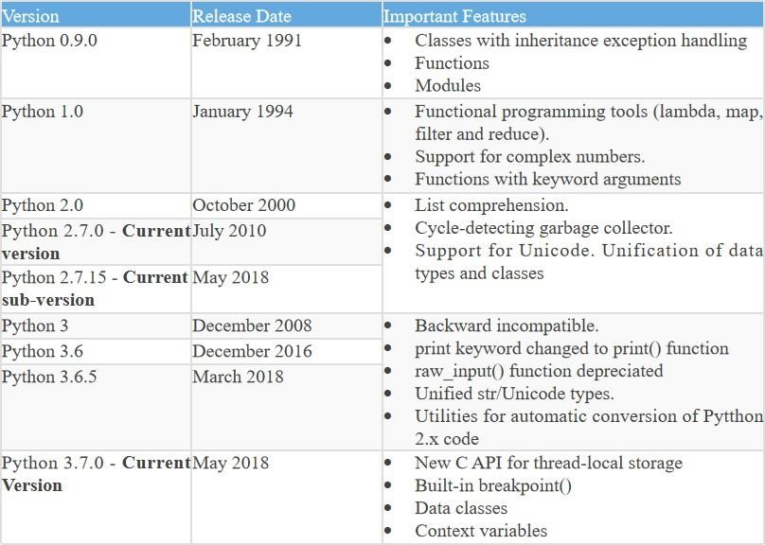

## FEATURES OF PYTHON:

Python is an interpreter-based language, which allows execution of one instruction at a time.

Extensive basic data types are supported e.g., numbers (floating point, complex, and unlimited-length long integers), strings (both ASCII and Unicode), lists, and dictionaries.

Supports object-oriented programming concepts such as class, inheritance, objects, module, namespace etc.

Supports automatic memory management.

The following primary factors cited by Python users seem to be these:

1. **It is free (open source):** Downloading and installing Python is free and easy. Source code is easily accessible.
2. **Python is object-oriented:** It supports concepts such as polymorphism, operator overloading, multiple inheritance, etc.
3. **Indentation:** This is one of the greatest features in Python.
4. **Readability:** Python programs use clear, simple, and concise instructions that are easy to read even by those who have no substantial programming background. Programs written in Python are, therefore, easier to maintain, debug, or enhance.
5. **Higher productivity:** Codes used in Python are considerably shorter, simpler, and less verbose than other high-level programming languages such as Java and C++. In addition, it has well-designed built-in features and standard library as well as access to third party modules and source libraries.
6. **It's mixable:** Python can be linked to components written in other languages easily. Linking to fast, compiled code is useful to computationally intensive problems.
7. **It's easy to use:** No intermediate compile and link steps as in C/ C++. Python programs are compiled automatically to an intermediate form

called bytecode, which the interpreter then reads. Structure and syntax are intuitive and easy to grasp.

## PYTHON SYNTAX:

Python syntax refers to the set of rules that defines how human users and the system should write and interpret a Python program.

## Keywords/Reserved words:

Python keywords are reserved words in Python that should not be used as variable, constant, function name, or identifier in your code.

Python 3.x interpreter has 33 keywords defined in it.

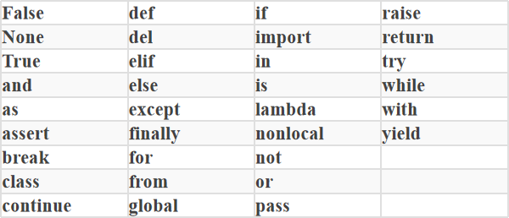

## Identifier

Python identifier is a name used to identify a variable, function, class, module, or other object. An identifier starts with a letter A to Z or a to z or an underscore (_ ) followed by zero or more letters, underscores and digits (0 to 9). Ex: myClass, my_variable, var_1, print_hello_world. Python does not allow punctuation characters such as @, $, and % within identifiers. Python is a case sensitive programming language.

Here are naming conventions for Python identifiers

* Class names start with an uppercase letter.
* All other identifiers start with a lowercase letter.
* Starting an identifier with:
  + Single leading underscore indicates that the identifier is private.
  + Two leading underscores indicates a strong private identifier.
* If the identifier also ends with two trailing underscores, the identifier is a language defined special name.
* Use the semicolon ; to write multiple statements in a single line.

## Quotation in Python

We Use quotation marks to indicate string literals. Python accepts single ('), double (") and triple (''' or """) quotes to denote string literals, as long as the same type of quote starts and ends the string. The triple quotes are used to span the string across multiple lines. To put both single quotes and double quotes inside of a string, wrap the string in triple quotes.

Use the escape character \ before double or single quotes to include them in the string. To put single quotes inside of a string, wrap the string in double quote

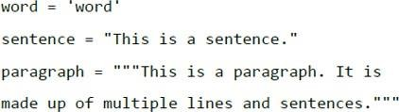

## Getting User Input

input() function is a part of the core library of standard Python distribution. It reads the key strokes as a string object which can be referred to by a variable having a suitable name.

## Display the Output

Built-in function print() serves as an output statement in Python. It echoes the value of any Python expression on the Python shell.

## Lines and Indentation

Python does not use braces({}) to indicate blocks of code for class and function definitions or flow control. Blocks of code are denoted by line indentation, which is rigidly enforced.

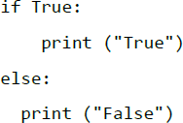

## Comment

A hash sign (#) that is not inside a string literal is the beginning of a comment. All characters after the #, up to the end of the physical line, are part of the comment. Python interpreter ignores them.



## VARIABLES:

A variable is like a container that stores values that you can access or change. One of the important features of Python is that it is a

dynamically-typed language. Programming languages such as C, C++, Java, and C# are statically typed languages. The prior declaration of variable's data type is not possible. In Python, the data assigned to a variable decides its data type. This is why Python is called a dynamically-typed language.

## Assigning value to variable

Python variables do not need explicit declaration to reserve memory space. The declaration happens automatically when you assign a value to a variable. The equal sign (=) is used to assign values to variables. **Syntax:**

**<variable name> = <value>**

## Multiple Assignment

Python allows you to assign a single value to several variables simultaneously.

Example: a= b = c = 1 a, b, c = 1, 2, “john“

## CHAPTER 4

* 1. **MODULES/LIBRARIES****:**

## SUBPROCESS

* + - **RE**

## EMAIL.MESSAGE

## SMTPLIB

* 1. **SUBPROCESS:**

## PRE-REQUISITES

* The subprocess module allows you to create a new process, connect it to its input / output / error pipes, and get the return code. This module will replace several previous modules and feIn Python, a subprocess is a task that a script delegated to the operating system (OS).
* We can use the subprocess library to run and manage subprocesses straight from Python. Working with the standard input stdin, standard output stdout, and return codes are all part of thes

## 4.2.1 INSTALLING SUBPROCESS:

* **WINDOWS**

Subprocess module comes pre-installed.

## LINUX

Subprocess module comes pre-installed.

**4.2.2 HOW IT WORKS:**

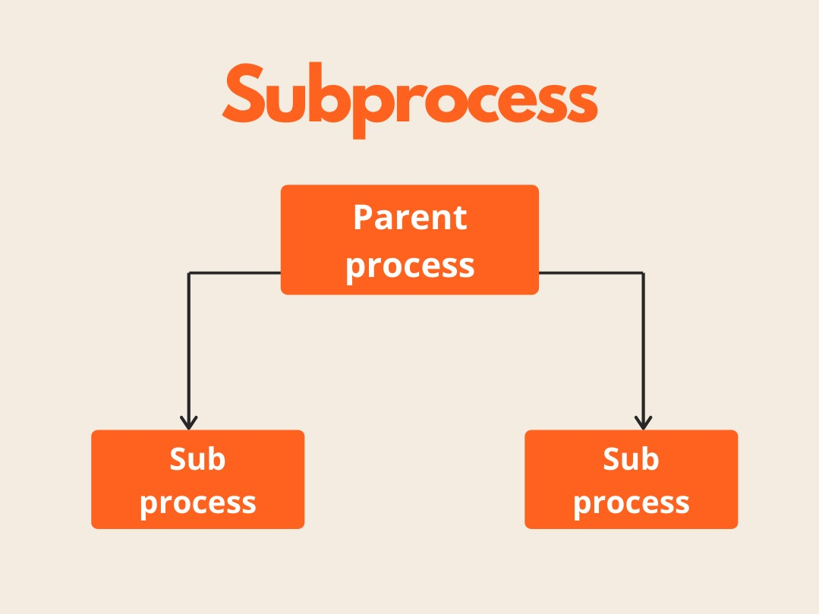

**4.3 RE**

## 4.3.1 INTRODUCTION:

* This module implements regular expression matching in the same way that Perl does.
* Patterns and strings to be searched can be both Unicode and 8-bit strings (str) (bytes). Unicode strings and 8-bit strings, on the other hand, cannot be mixed: a Unicode string cannot be matched with a byte pattern, and vice versa; similarly, when requesting a substitute, the replacement string must be Unicode.

## FEATURES:

## With optional flags, this method looks for the first occurrence of the RE pattern within a string.

## This function's syntax is as follows

## re.search(pattern, string, flags=0)

## Parameters description

|  |  |
| --- | --- |
| **Sr.No.** | **Parameter & Description** |
| 1 | **pattern**  This is the regular expression to be matched. |
| 2 | **string**  This is the string, which would be searched to match the pattern anywhere in the string. |
| 3 | **flags**  You can specify different flags using bitwise OR (|). These are modifiers, which are listed in the table below. |

## INSTALLATION:

pip install re

## IMPORTING:

From re import *

## EMAIL.MESSAGE:

## INTRODUCTION:

## The EmailMessage class, imported from the email.message module, is the heart of the email package. It is the email object model's foundation class. Setting and querying header fields, accessing message bodies, and creating or changing structured messages are all provided by EmailMessage.

## INSTALLATION:

pip install email.message

## IMPORTING:

from email.message import EmailMessage

# SMTPLIB:

* + 1. **INTRODUCTION:**

Connecting to a mail server and sending a message is the most common use of SMTP. You can either pass the mail server's host name and port to the function Object() { [native code] } or use connect() explicitly. Simply call sendmail() with the envelope parameters and message body once connected. Because smtplib does not change the contents or headers, the message text should be a fully formed RFC 2882-compliant message.

* + 1. **COMMONLY USED COMMANDS:**

Smtp.login() smtp.ehlo() smtp.has_extn()

Smtp.starttls() etc..

* + 1. INSTALLATION:

This module comes inbuilt with the python package ,so no need to install again.

To use this module, one should use import command i.e

**Import smtplib**

* 1. **OVERALL:**

To introduce necessary modules, use pip command. Bringing the modules.

After importing modules, creating empty list for Wi-Fi details to capture

Passing some netsh commands to get details of saved Wi-Fi networks.

Characterizing the capacities.

## Import Libraries

Start by bringing in the libraries- re,subprocess,smtplib,email.message.

**4.6.2 Passing commands**

Netsh commands are passed to get saved Wi-Fi details.

**4.6.3 Getting the data**

Saving the data in a list.

**4.6.4 creating the msg body using collected list.**

Using the extracted list ,the SSID and pass key are arranged in a email msg body.

**4.6.5 connecting to SMTP server**

Smtp server is established and mail is sent to user given mail address

## CHAPTER 5:

**ALGORITHM:**

 **START**

 **RUNNING NETSH COMMANDS**

 **GETTING RESULTS FROM THE COMMANDS AND SAVING THE DATA IN LIST**

 **CREATING MAIL FOR RECEPIENT WITH BODY AS SSID’s AND PASSKEY**

 **ENTER THE MAIL ADDRESS FOR WHICH THE DATA SHOULD BE SENT**

 **SENT!!!**

 **END**

# CHAPTER 6

**EXPECTED OUTPUT**

# Expected output 1

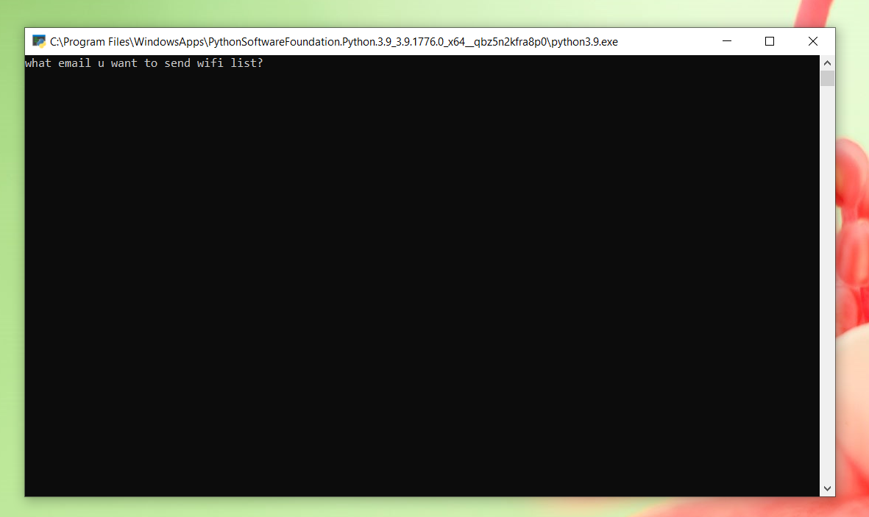

**Expected output 2**

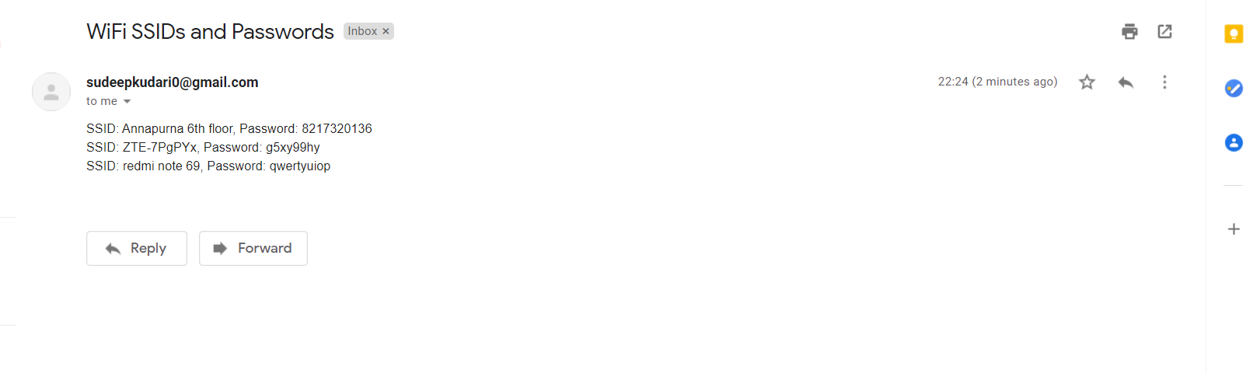

## CHAPTER 7 CONCLUSION:

This python code requires some modules which has to be imported to run this code.

As of now this code works only in windows os, which can run netsh commands. This application can be used to recover forgotten Wi-Fi passwords.

This application can also be used to snipe the Wi-Fi password from strangers laptops.

Mainly Python is used to automate tasks which this application does by getting Wi-Fi lists with passwords

**CHAPTER 8 REFENRENCES**

7.1 WEBSITES

1. [www.geeksforgeeks.com](http://www.geeksforgeeks.com/)
2. [www.tutorialspoint.com](http://www.tutorialspoint.com/)
3. [www.w3schools.com](http://www.w3schools.com/)
4. [www.programiz.com](http://www.programiz.com/)